

**Gulf Aluminium Rolling Mill B.S.C.**

**ICT Department**

**CEA / MRE System**

***Software Requirement Specifications***

Document Revision History:

|  |  |  |  |
| --- | --- | --- | --- |
| **Version** | **Date** | **Remarks** | **Author** |
| 1.0 | 26 June 2022 | Draft created | Ervin Brosas |
|  |  |  |  |
|  |  |  |  |
|  |  |  |  |

Document Approval (Sign-off):

|  |  |  |  |
| --- | --- | --- | --- |
| **Approver Name** | **Position** | **Signature** | **Date** |
| Khalid Jalal | Sr. Group ICT Manager |  |  |
|  |  |  |  |
|  |  |  |  |
|  |  |  |  |

Table of Contents

1 INTRODUCTION 4

1.1 Project Owners 4

1.2 Audience 4

1.3 Purpose 4

1.4 Project Overview 4

1.5 System Glossary 4

2 PROJECT SCOPE 5

2.1 Business Problem 5

2.2 Application Scope 5

2.3 Integration with other Systems 5

3 FUNCTIONAL REQUIREMENTS 5

3.1 Budget Management 5

3.1.1 Creation of Projects 5

3.2 Expenditure Request Management 6

3.2.1 Creating an Expenditure Request 6

3.2.2 Integration of Purchase Requisition 8

3.2.3 Tracking of Expenditure Request 8

3.2.4 Maintenance of Completed CEA 8

3.2.5 Validations 9

3.2.6 Non-functional 9

3.3 Approval Group Management 9

# INTRODUCTION

This chapter is to introduce the project, its purpose, and structure.

## Project Owners

The project owners comprise of the Department Managers and Management Executives.

## Audience

This document is intended for third party suppliers who could provide a software solution based on the functional requirements defined in this document. This is also intended for Finance and Engineering Stakeholders for their perusal on various functionalities that will be implemented in the system, as well as to identify any additional requirements as needed.

## Purpose

The purpose of this document is to identify the system requirements and the proposed solution to the audience. This document will be used by the 3rd party vendors as basis for providing a software solution that would meet the functional requirements of the system. Project owners will sign-off on all requirements before presenting it to potential vendors.

After sign-off, any requested changes to the requirements will be documented including the effect on the project costs, scope and timelines and presented to the project owners for approval. These requirements were gathered based on ICT understanding of the user requirements.

## Project Overview

The CEA/MRE System is designed to enhance the user experience with respect to creating a request electronically without filling out any paper-based forms. The system has built-in dynamic workflow engine which automates the approval process and sending of email notification to the approver. Users can track the progress or status of their request and can view the approval history. The system also provides functionality to search for requisition list based on predefined filter criteria as well as provide robust statistical reports.

The system addresses the following primary business challenges:

1. Automate the Expenditure Request process
2. Eliminate delays in the manual approval process
3. Reduce human errors and delays of searching for data to fill out manual forms
4. Seamless integration with other systems such as JDE OneWorld, TAS, and GAP.

## System Glossary

|  |  |
| --- | --- |
| Term | Description |
| CEA | Capital Expenditure Addition |
| MRE | Major Revenue Expenditure |
| INC | Item Non-Capitalized |
|  |  |

# PROJECT SCOPE

## Business Problem

The current CEA/MRE System is reaching the end of its lifetime due to the outdated technologies been used which lead to its cumbersome maintenance. Though the system is still operational, the ever-changing internet browser updates could lead to unresolved compatibility issues and may result to system malfunctions.

## Application Scope

The CEA/MRE system will serve as the source for requesting expenditure, which is submitted to an online approval process. Users will be able to track the request any time online, which will indicate the current status and the next status. The system automates the approval process based on the workflow setup and will send email notification to the approver or to the defined substitute during their absence.

## Integration with other Systems

The CEA/MRE system will receive information from the following systems.

|  |  |
| --- | --- |
| JDE OneWorld | Information such as budget, cost centers, descriptions, employee ID’s etc. |
| GARMCO Active Directory | User security information such account name, user id, etc. |
| GAP (GARMCO Application Portal System) | Employee leave information |

# FUNCTIONAL REQUIREMENTS

## Budget Management

The budget management function would help the user to manage budget related information, which is used as a source in the process of creating an expenditure request.

### Creation of Projects

The finance department, at the beginning of the fiscal year, would upload all the approved CEA / MRE budgets into the system; conforming to the format (MS Excel sheet) defined by ICT department.

The typical information includes the following: Fiscal Year, Expenditure Type, Cost Centre, Project Number, Expense Category, Description, Detailed Description, Budget Amount, etc.

Currently, there are 3 expenditure types used in the system which include the following:

1. CEA – Capital Expenditure Addition
2. MRE – Major Revenue Expenditure
3. INC - Item Non-Capitalized

## Expenditure Request Management

This function would provide a set of features to manage the expenditure request. The completed expenditure request will be uploaded to JDE OneWorld.

### Creating an Expenditure Request

The initiator will create an expenditure request by entering the relevant information based on the project details.

The initiator would select an Item Type when creating an expenditure request. This can be any of the following types:

* Computer Related
* Human Resources
* Civil Engineering
* Mechanical Engineering
* Electrical Engineering
* Administration
* Transportation Related
* Furnitures and Stationaries
* Medical Related
* Safety Related
* Projects
* Office Equipment
* Quality Related
* Maintenance Related

Expenditure requests are mapped to an approval group. Once all information is provided, the initiator will submit the request and would then initiate the approval process. Additionally, the system will facilitate the attachment of relevant external documents to the request. External documents can be attached only by the initiator or the department managers.

The system will check the available budget for the requested project. If the budget amount is not sufficient for the request, the system will notify the initiator who created the expenditure request and the department manager.

The following workflow approval process will take place upon submission of an expenditure request.

1. The request will be assigned to the Originator for approval. *(Notes: The Originator is the person who will check the accurateness of the information given in the request and is specified by the initiator during request submission.)*
2. Once the Originator approves the request, it will undergo cost center approval which involves the following roles:
   1. Superintendent – refers to the Head of the department
   2. Cost Center Manager – refers to the Manager of the department

*(Notes: In some departments, Superintendent and Cost Center Manager role refers to the same person. In such scenario, only one approval is required.)*

1. After the cost center approval is completed, the request will go to the Executive Manager – Operations if the Originator’s cost center is any of the following:
   1. 3250 – ROLLGRINDING
   2. 5200 – MECHANICALENGINEERING
   3. 5300 – ELECTRICALENGINEERING
   4. 5400 - CENTRAL ENGINEERING

Otherwise, the request will go to the Executive Manager – Finance for approval.

1. If the request is budgeted and the amount is greater than BD 20,000, or if the request is not budgeted and the amount is greater than BD 5,000, it will go to the following roles for approval in sequential order:
   1. General Manager
   2. Chief Executive Officer
2. If the request is budgeted and the amount is greater than BD 100,000, or if the request is not budgeted and the amount is greater than BD 50,000, the request will be assigned to the Chairman for final approval.

Once the approval process is completed, the request will be set into “Approved” status. All approved CEAs will be uploaded to JDE manually by the Executive Personal Assistant. This person has the authority to view all approved CEA requisitions in the system and can post it to JDE by clicking the “Upload to JDE” button.

At each approval level, the application checks the Leave Requisition module, which is a separate system, to validate the availability of an approver. If an approver is on-leave, the workflow will automatically assign the request to the substitute if it’s defined in the leave request. Otherwise, it will be assigned to the original approver.

Below outlines the item category approvers as well as the workflow approval process.

**Item Category Approvers:**

|  |  |
| --- | --- |
| **Item Type** | **Approver Roles** |
| Administration | General Manager |
| Furniture & Stationary | General Manager |
| Maintenance Related | General Manager |
| Medical Related | General Manager |
| Office Equipment | General Manager |
| Projects | General Manager |
| Quality Related | General Manager |
| Civil Engineering | Executive Manager - Operations |
| Electrical Engineering | Executive Manager - Operations |
| Mechanical Engineering | Executive Manager - Operations |
| Computer Related | Senior Group ICT Manager |
| Human Resources | Executive Manager - Administration |
| Safety Related | Head of HSE |
| Transportation Related | Head of HSE |

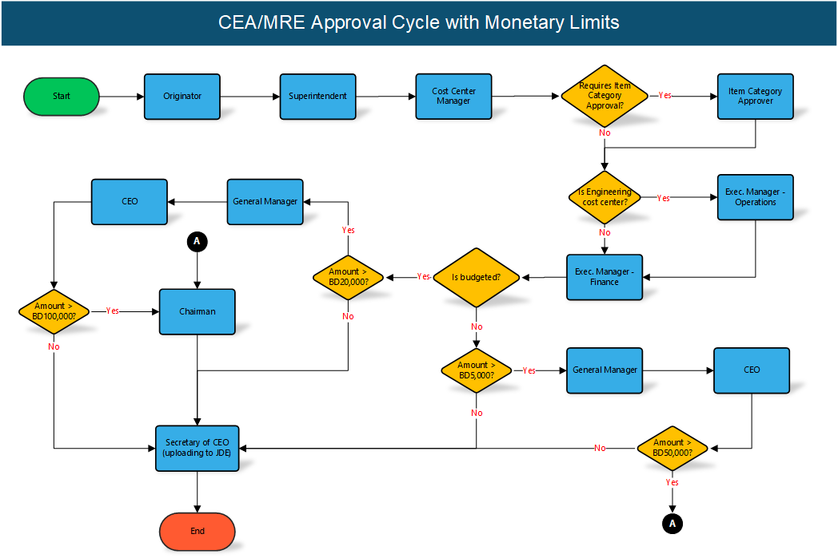

### Integration of Purchase Requisition

Once the CEA request is approved and posted in JDE, a Purchase Requisition request can be created to consume the CEA request. The PR system will automatically fetch the relevant information about the CEA request and display it in the data entry form.

### Tracking of Expenditure Request

The system provides a facility to track the expenditure request in various statuses such as creation, pending for approval, final approval, budget approved, budget not approved, etc.

### Maintenance of Completed CEA

The finance department will have functionality to close completed Projects and CEA requests for specific fiscal year. No CEA request can be created against a close or cancelled Project. Likewise, no Purchase Requisition request can be created against a closed or cancelled CEA/MRE request.

### Validations

The full report about the CEA/MRE request can only be printed if the approval process is completed.

### Non-functional

All entries, user actions will be logged for audit purposes.

## Approval Group Management

The system provides a functionality to create approval groups and map them to each department as well as to the Expenditure Item Type. Each approval group will have its fixed signatories. The Superintendent, Cost Center Manager, and CFO approver roles will be common for all departments.

System Administrators can add any number of signatories for digital approval in addition to the mandatory list, hence, the approval group will be dynamic and customizable.